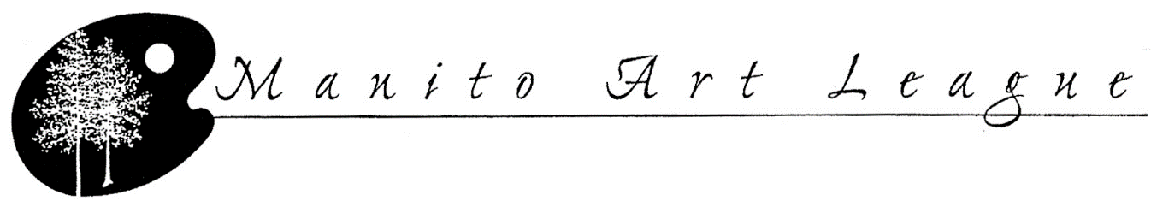
MANITO ART LEAGUE 2017 SCHOLARSHIP FOR TUITION
AT A COLLEGE, UNIVERSITY OR PROFESSIONAL SCHOOL
INSTRUCTIONS, INFORMATION AND APPLICATION

Manito Art League Scholarships are available for anyone living within or attending an accredited school within a 70-mile radius of Manitowish Waters, Wisconsin. Applicants must be a graduating high school senior, a college student, or an adult 18 years or older interested in any of the fine arts, such as the following:

Art Theater Music Architecture Graphic Design Vocal Performance Animation Songwriting Photography Music Education Game Design Art Education Video Production Creative Writing Dance

Scholarships are for tuition only and usually range from $500-$2000, depending on the number of applicants. The Art League has awarded more than $200,000 in scholarships since 1979. Scholarships must be used by May 2, 2018.

Besides the MAL Scholarship there are two other scholarships with specific requirements.

Polly H. Ullrich Scholarship for Early Career Artists
This is a yearly scholarship in the amount of $2000 towards tuition and related expenses at an accredited college or university, not for profit, public or private, or professional school. The scholarship will be awarded to anyone under 30 years of age, within a 70-mile radius of Manitowish Waters, WI seeking to be an early career artist.

Rutherford/Raedeke Memorial Scholarship
This $500 yearly scholarship is awarded towards tuition only to a Wisconsin resident. Recipient must be a high school graduate enrolled as a full-time student in a bachelor, master, or doctor of philosophy degree at a four-year college or university and majoring in fine arts.

Requirements
Fill out the MAL Application form.
Write a minimum one-page essay that explains how this course of study, class or workshop will help fulfill your artistic goals addressing the importance of the medium used. Included in that essay is the need for financial aid.
Three examples of the artist’s works via picture or .jpg; or three 1-minute videos for dance, vocal or musician

The scholarship application deadline is May 15, 2017; this is an earlier due date than
previous years.

After all the applications are received, decisions will be based upon the total number of applicants, the essay explaining financial need and describing how the applicant’s artistic goal will be met by receiving the award, and the sample pictures of the artist’s works. The Polly Ullrich Scholarship will be chosen first, followed by the Rutherford/Raedeke. Depending on the number of applicants, the remainder will receive the Manito Art League Scholarship. Please do not call about the status of your application. The Scholarship Committee will notify you as soon as possible so your school can include your award for graduation ceremonies.

The Manito Art League Art Show will be held July 20-23, 2017 at the Manitowish Waters Community Center. If you are awarded a scholarship, we ask that you volunteer to work for a shift of 2-3 hours at the Show. You will be responsible for calling the Chairperson to schedule your hours. While this is not a requirement for the scholarship, it is greatly appreciated. We would also like you to exhibit one piece of artwork in the Art Show, with no entry fee for this piece. You are cordially invited to be our guest at the Patrons’ Preview, the opening of the Show on the Wednesday, July 19th when you can meet the patrons who sponsor the scholarship fund.

Scholarship applications are also available at www.manitoartleague.weebly.com our MAL website. All applications will be accepted from September 2016 through May 15, 2017. Email to manitoscholarships@gmail.com. If mailed, they must be postmarked by the May 15, 2017, the application deadline.

Mail to: Manito Art League Scholarship Committee
C/o Marilyn Feldkamp
5268 Avenue of Birches
Manitowish Waters WI 54545

Feel free to email us at manitoscholarships@gmail.com or call if you have questions, Marilyn Feldkamp, 715-543-2149. All applicants will be notified as soon as possible after the due date.

Thank you for applying. Good luck in your pursuit of the arts!

Important Dates

May 15, 2017 – Scholarship Application deadline
July 16 – Artwork received
July 19 - Patrons’ Preview Award Night
July 20-23 Manito Art League Show
July 23 – Artwork pickup

MANITO ART LEAGUE 2017 SCHOLARSHIP APPLICATION
FOR TUITION AT A COLLEGE, UNIVERSITY OR PROFESSIONAL SCHOOL

Name_____________________________________________________________Date_______________

Address______________________________________________________________________________

Phone____________________________Email______________________________________Age______

School currently attending, if applicable____________________________________________________
Years of education completed (must be over 18 or high school graduate) _________________________
If currently in school, overall grade average__________________________________________________
Specialty: Visual Arts_________ Performing Arts__________ Writing_________ Other______________

Please describe your area of interest_______________________________________________________

What are your goals in the art field? _______________________________________________________
_____________________________________________________________________________________

Other scholastic interests________________________________________________________________

Extra-curricular activities_________________________________________________________________

Give the complete name and address of the school you are presently planning to attend in 2017:
_____________________________________________________________________________________
______________________________________________________________________________________
______________________________________________________________________________________

Have you ever received?
Rutherford/Raedeke Memorial Scholarship? Yes/Year ______ No______
Manito Art League Scholarship? Yes/Year ______ No______
Polly H. Ullrich Scholarship for Early Career Artists? Yes/Year ______ No______

Required Essay: Please include a one-page essay that explains how this course of study, class or workshop will help you fulfill your artistic goals addressing the importance of the medium used; and explain your need for financial aid.

Required Media Examples: Please also include 3 examples of your artistic work via .jpg, pictures, or three 1-minute videos (for dance, vocal, musician)

Due Date: May 15, 2017 Please send this application, your essay and samples by email to manitoscholarships@gmail.com or mail to:
Manito Art League Scholarship Committee
C/o Marilyn Feldkamp
5268 Avenue of Birches
Manitowish Waters WI 54545

See accompanying letter for further qualifications

